

**ELEC S411F (2020/21)**

**Electronic and Computer Engineering Project**

**Final Report**

|  |  |
| --- | --- |
| Deceptive Angry Birds | |
|  |  |
| Project number: | B02 |
| Student name | Yu Siu Chung Brian |
| Supervisor: | Bruce Tong |
| Submission Date: | 8th Mar, 2021 |

**Declaration of Originality**

I, [Yu Siu Chung Brian], declare that this report and the work reported herein was composed by and originated entirely from me. This report has not been submitted in any form for another degree or diploma at any university or other institute of tertiary education. Information derived from the published and unpublished work of others has been acknowledged in the text and a list of references is given in the reference section.

[3rd Mar, 2021]

**Abstract**

Artificial Intelligence (A.I), is a kind of technology which used in many different fields, such as smart phone, television, sound bar, search engines, etc. A.I mean the machine can show intelligence and make them learning, make decision, communication, action like human. Nowadays, A.I. has start to become mature and solve some complicated problem or activities. After A.I beat human in Chess and Co, some people try do use A.I. to challenge a game called ‘Angry Birds’. Since 2012, the 1st Angry Birds AI competition was held in Sydney. Many different types of A.I. agents were developed in the competition. But the A.I agents still not perform better than human as Chess and Go.

This report describes the background information, the motivation, the test, analysis about those A.I agents which were participated in the Angry Birds AI competition. Also, design some game level in Science Bird (similar game as Angry Birds) to trick the A.I. agents and give some suggestion to improve the A.I. agents.

The following are covered by the report:

* The background information of the Artificial Intelligence, Angry Birds, Science Birds, Angry Birds AI competition
* Analysis of the A.I. agents performed in Angry Birds and Science Birds
* Explanation of the design direction of the game levels in Science Birds which can fool those current state-of-the-art agents
* Suggestion of the improvement of those A.I. agents which tested

**Table of Contents**

**1.** **Introduction** 4

**1.1 Motivation** 4

**1.2 Project Objectives** 5

**1.3 Organization of the Report** 5

**2.** **Background** 6

**2.1 Artificial intelligence** 6

**2.2 Angry Birds and Science Bird** 7

**2.3 Server-Client Architecture of Angry Birds Software** 10

**2.5 Background information of A.I. agent** 12

**2.6 Angry Birds AI Competition** 14

**3.** **Design / Methodology** 14

**3.1 Project Equipment and Environment Set up** 14

**For Angry Bird (Offline Mode)** 15

**For Science Bird** 15

**3.2 Setup of the Angry Birds in Chromium** 15

**3.3 Methodology of Record the performance of the A.I agents in Angry Birds and Find the weakness of the A.I agents** 16

**3.4 Design the game level in Science Birds and Test the A.I. agents** 17

**4.** **Implementation / Experiment** 18

**4.1 Difficulties of setting the environment for a.i. agents** 18

**5.** **Results and Discussion** 31

**5.1 Discussion of the performance of A.I. agent play in Angry Brid** 31

**5.2 Deceptive element leads poor shot** 33

**6.** **Conclusion and Further Work** 34

**References** 35

**Appendix** 36

## **Introduction**

### **1.1 Motivation**

Since 1970, the memory of the computer has been improving rapidly. The computer can collect and save data easily. The development of Artificial Intelligence (A.I) is growth very fast in 20th century. The A.I. technology already apply in many different fields, such as transportation, medic, Art design, video game. After Covid-19 virus affect global business, many companies have start put more capital on A.I. technology to reduce human cost and improve efficiency. Therefore, A.I. must be big trend in the future.

In the mid 1990s, computers bean to win master level’s chess players in exhibition matches. The world chess champion Garry Kasparov was beat by an artificial intelligence called Deep Blue which created by IBM in 1997. Deep Blue became the first non-human world chess champion after won Garry. After A.I. success in chess, a computer programs company called DeepMind which was acquired by Google that created an A.I. program called AlphaGo to challenge another board game Go. Go is a more difficult and combination than the Chess. Before AlphaGo appeared, there are no computer can win professional Go players. But AlphaGo defeated Lee Sedol who was the world champion and Jei Ke who is the 1st ranked players. Finally, it’s completed version AlphaGo Zero becomes the best Go player in the world too. Although artificial intelligence seems become popular, it still not performs well in gaming.

In old day, the game “Pac-Man" already had similar programming technology like A.I.   
The computer will control four ghosts to chase player automatic. Nowaday, the game developer will use A.I to do game testing and game analysis. Therefore, some people want A.I. to challenge in gaming after challenge in board game like chess and Go. In 2019, there are unexpected result in Man vs Machine Challenge [1] in ‘Angry Birds’ which is a famous game in smart phone. A.I. agents can shoot the targets accurately but they still easy to be tricked in some game levels. Human beat A.I at Angry Birds and A.I still has a long way to become to master in this game. So, what is the reason why human still can win in Angry Birds?

### 

### **1.2 Project Objectives**

* Analysis the characteristics of the A.I agents in Angry Birds and Science Birds
* Install the A.I agents and run it to play those game
* Record the scores, time spend, each shot’s priority or step in each level
* Indicate the weakness of the A.I agents
* Design the game levels that can fool the A.I agents in Science Birds
* Create the game level by the Unity
* Run the A.I. agents to play those game level

### **1.3 Organization of the Report**

* Chapter 2 gives a background of the Artificial Intelligence, Angry Birds, Science Birds, the construct of the naive agent, the design of A.I. agents which tested in this report
* Chapter 3 describes the method of record the performance of different A.I agents in games and setup of the equipment
* Chapter 4 data collected by Angry Birds and Science Birds and analysis
* Chapter 5 sum up the weakness of the
* Chapter 6 describes the suggestion improvement to those A.I agents
* Chapter 7 evaluates the achievements of this project

## **Background**

This chapter introduces the concept of the artificial intelligence in Section2.1. Section 2.2 describes the characteristic and elements of the game “Angry Birds” which is the game playing software used in the A.I Birds Competition and “Science Birds” is one of the software for design own game levels in this project. In Section2.3, describe the server-client architecture of the Angry Birds Software. This is the prototype of the A.I. agents which created by the team joined the A.I Birds Competition. In Section 2.4, introduce the designn ot the A.I agents which tested in this report. In Section 2.5, introduce the A.I Birds Competition.

### **2.1 Artificial intelligence**

In this subsection, it gives a briefly introduction to the concept of Artificial Intelligence (A.I).

A.I. is in include computer science, information engineering, mathematics, psychology, etc. It was first used at “The Dartmouth Summer Research Project” at Dartmouth in 1956. It works by many tools such as statistical method, probability, etc. Normal, A.I agent will record the environment or picture by a sensor by the machine. This action seems like human watching or listening. Then, the A.I agent will change every object into different kind of data in different vectors according program setting. Those data will become the input, and the A.I agent will do the corresponding action according the programing by the designer of the A.I agent. For the example of this project, the computer will do the screenshot before each shot. The A.I agent will collect the data such as the location of the big, the type of the bird using by the picture of the screenshot. Then, computer will calculate the path of shooting of the birds. Finally, computer will shoot automatically. The detail of the gameplay of the Angry Birds will explain in Section 2.2.

In “Big Data” generation, the Artificial Intelligence evolve to the machine learning and deep learning. They can do more possible things and perform better than human in many fields. Such as strategic game: chess and Go, imperfect-information games like poker, solving Law task, etc. Angry Birds is one of a gaming software still human better than computer.

### **2.2 Angry Birds and Science Bird**

Angry Birds

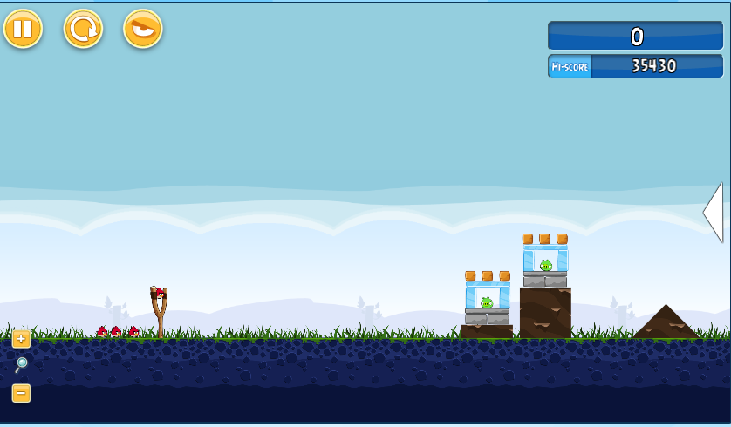

**Figure 1: Screenshot of the Angry Birds game**

In December 2009, the Finnish company Rovio Entertainment released the first game of the series for iOS platform. It is a kind of physics-based puzzle game. Player uses a slingshot to shoot birds at pig. Player need hit all the pig to complete each level. Beside the pig, there are many different blocks in each level. The blocks made of one of three materials, wood, stone or ice. Sometime, the blocks can protect the pigs or help the player to hit the pigs (when the blocks fall down and hit the pigs.) Every movement and action obey the simplified physics principles defined in game. All objects have their own size, mass, density, etc. In game, Birds have different type and they have different function. Player can control power and angle when firing the birds, also tap the screen again to active the birds’ ability. After the player complete the level, the system of the game will give the score to player according the number of birds remaining and total amount of damage did at those level.

**Table 1 The function of the Birds in Angry Birds**

|  |  |
| --- | --- |
| Birds | function |
|  | regular; no ability |
|  | split into three small birds when; strong against ice |
|  | accelerate when click; strong against wood |
|  | explode when click and after impact; strong against rock |
|  | Drop explosive egg when click |

Science Birds

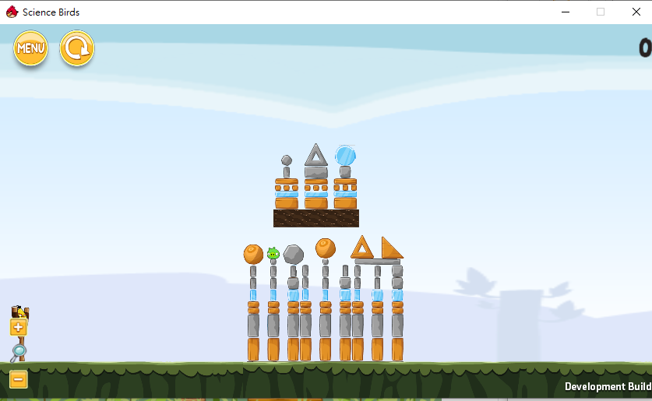

**Figure 2: Screenshot of the Science Birds game**

A cover version of the “Angry Birds” for research use. All the elements are the same. The several game objects have birds, blocks, TNTs, pigs, etc. The Birds still have different color and different function. The Science Birds is made by Lucas Ferreira and Claudio Toledo in 2014. The Science Birds can run the level which is designed by the player themselves. The level designer can use the game engine called Unity to create their own level.

### **2.3 Server-Client Architecture of Angry Birds Software**

In this project, the version of the Angry Birds game is 1.32. The Angry Birds Software is in Java environment and the version of Java is 7.

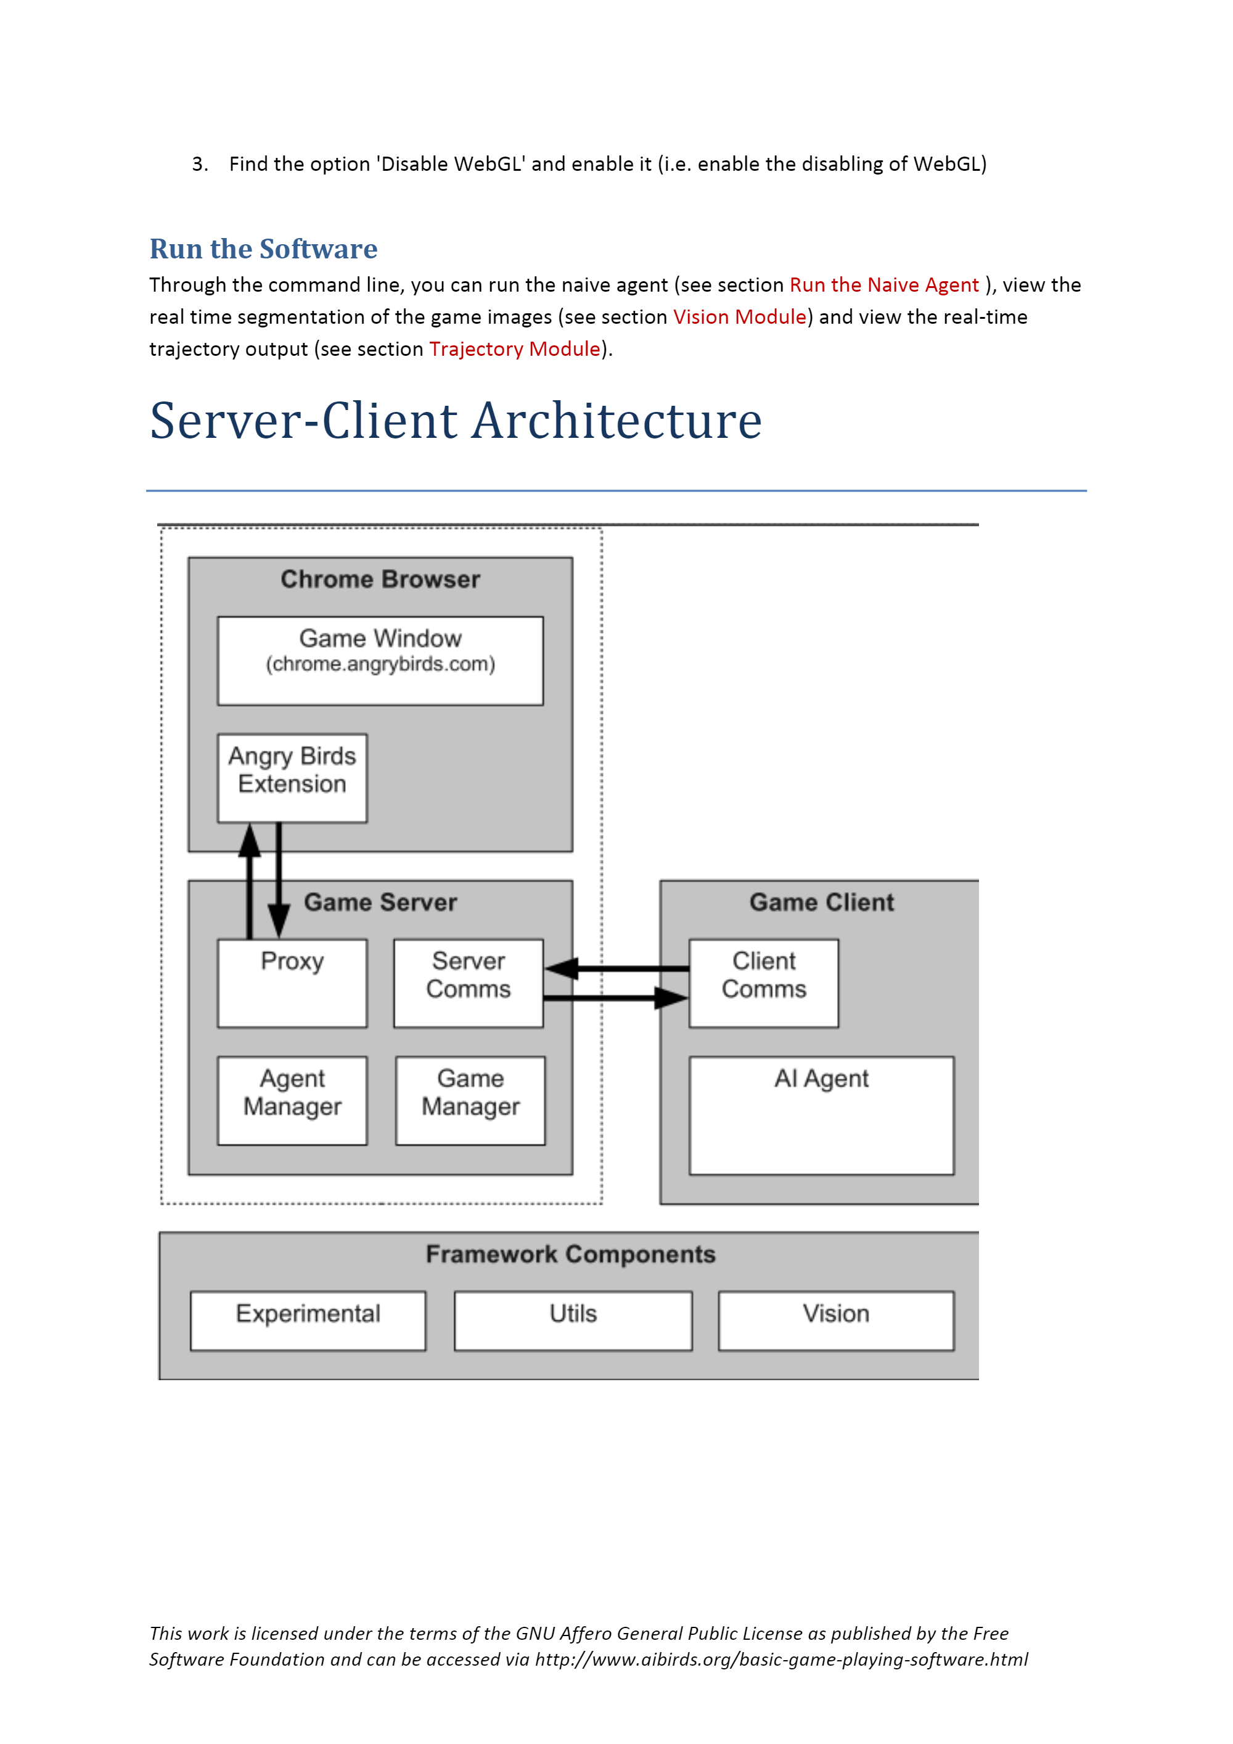

**Figure 3 the Server-Client Architecture of the Angry Birds**

According the Figure 3 , Proxy module is use to sending the message from Game Client’s command. For example, “Click” means left click the mouse, “Drag” means drag the cursor from one place to another. Angry Birds Extension is used to execute the action like capturing game window by the message from the proxy of the game server. The vision module at Framework Components in figure 3. It is composed of two image segmentation components. One of component sperate an image and produce a list of the minimum bounding rectangles of essential objects include: “Red Bird”, “Blue Bird”, “Yellow Bird”, “Black Bird”, “White Bird”, “Sling”, “Pig”, “Ice”, “Wood”, “Stone”, “TNT”, “TrajPoints”. Real shapes were produced by the other component. User can use them to process a screenshot.

**2.4 The Original source code of naive agent**

Different the A.I. agents are developed by the source code provide by the organization of the A.I. Birds competition. There are many files contain the JAVA code for the naive agent in different function, for example “connecting server, calculate the shape of objects, number of objects, the angle of shooting, etc”

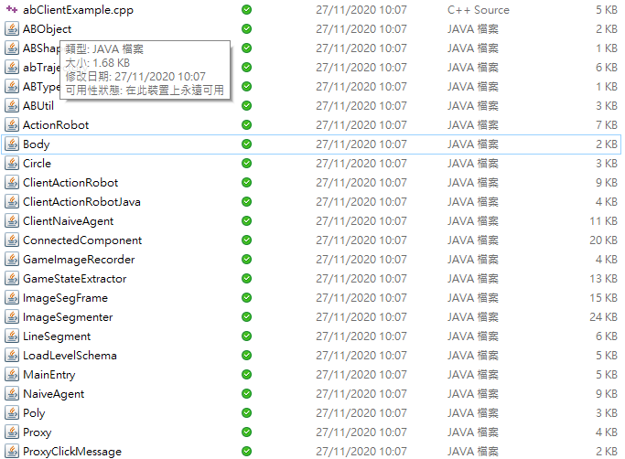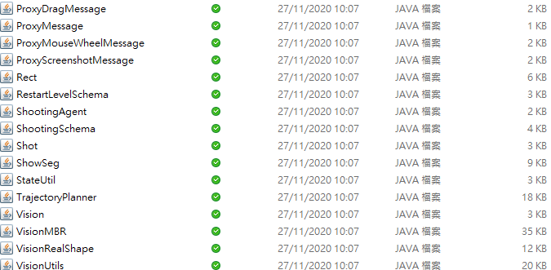

Figure 4: the JAVA code for naive agent

### **2.5 Background information of A.I. agent**

According the document [2], an agent analyzes game scenarios by the vision module and the trajectory module to plan on shots. The framework is written in java. But the agent can be implemented in the other languages such as python, etc.

In this Project, Five A.I agents were tested.

文字方塊文字方塊文字方塊文字方塊文字方塊

**Figure 5. A.I. agents include in this report**

*The BamBirds*

The winner of the 2019 Angry Birds A.I. Competition. By their description in their source code folder. They are come from the student from the University of Bamberg, Germany.

The first component of the BamBird agent is mainly using the interpreting screen shots and interacting with the game by the naïve agent framework. Then, generate a declarative description of the screen content, enriched by qualitative relations between individual objects and structures detected. It can improve precision of the description generated. Second component is determining possible shot candidates. By record the qualitative relationship of the objects, it is possible to calculate the shot which is most effective from the physical properties in game. Third component, A.I. agent implements the shot decision from the set of the candidates computed. It is used for retrying the uncompleted level before. By use of machine learning, A.I. agent designed to get the largest reward if the level which played before.

*IHSEV AIBirds*

In A.I. competition,

In 2013, 8th place (quarter-finalist), team IHSEV

In 2014, 4th place (semi-finalist), team IHSEV

ANU Open Day 2013: Angry Birds Man vs Machine Competition

In 2013, 1st place, team IHSEV

*AngryBER agent*

An intelligent agent architecture on the Angry Birds domain that employs a Bayesian ensemble inference mechanism to promote decision-making abilities. It is based on an efficient tree-like structure for encoding and representing game screenshots, where it exploits its enhanced modeling capabilities. This has the advantage to establish an informative feature space and translate the task of game playing into a regression analysis problem. A Bayesian ensemble regression framework is presented by considering that every combination of objects' material and bird type has its own regression model. It addresses the problem of action selection as a multiarmed bandit problem, where the upper confidence bound (UCB) strategy has been used. An efficient online learning procedure has been also developed for training the regression models. It has evaluated the proposed methodology on several game levels, and compared its performance with published results of all agents that participated in the 2013 and 2014 Angry Birds AI competitions. The superiority of the new method is readily deduced by inspecting the reported results.

*DQ agent*

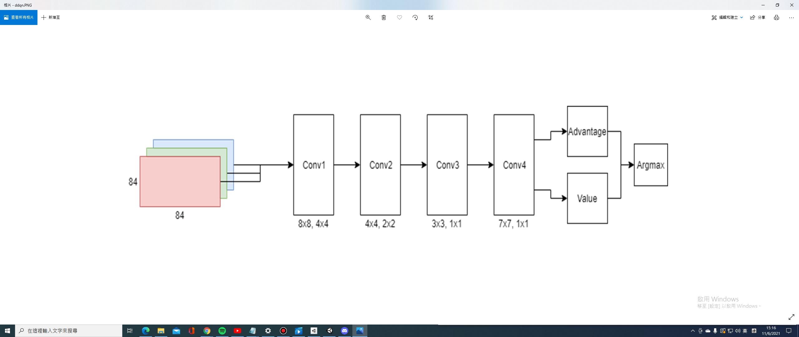

Figure 6. The architecture of Double Dueling Deep Q-Network

DQ-agent is participant in A.I. Birds competition since 2012. This agent takes a screenshot from specified folder and feeds it as input to the Double Dueling Deep Q-network. Deep-Q learning network of the sort used to successfully solve Atari games by DeepMind.

### **2.6 Angry Birds AI Competition**

It is the competition about the A.I. agent play a famous game in smart phone which called “Angry Bird. During the competition, all the team need run their A.I. agents to play the Angry Birds automatically within time limit. After that, the team get higher can play the knock-out rounds. The winner of the competition is the agent which get the highest combined game score in the knock-out rounds. But the number of teams that can enter the competition is limited. The team need pass the qualification round first. The competition held globally. The Organizers of the competition are Jochen Renz from Australian National University,XiaoYu (Gary) Ge from Australian National University, Peng Zhang from Australian National University,Hua Hua from Australian National University, Ekaterina Nikonova from Australian National University

## **Design / Methodology**

This section will describe the equirement used, the step of running the A.I agent, how to record the perfomances of the A.I. agents.

### **3.1 Project Equipment and Environment Set up**

The PC used in the project:

OS: Window 10

CPU: AMD Ryzen 5 3600 6-Core Processor 3.60 GHz

GPU: MSI GeForce GTX 1660 Ti

Ram: Crucial Ballistix RGB 16GB Kit (2 x 8GB) DDR4-3600 Desktop Gaming Memory

Motherboard: MSI B450M PRO-VDH Max

OS: MacOS

CPU: Intel 2-Core i5 2.7GHz

GPU: Intel Iris Graphics 6100 1536GB

Ram: 8 GB 1867 MHz DDR3

### **For Angry Bird (Offline Mode)**

Java: JDK 8

### **For Science Bird**

Java: JDK 12

Python: 3.6 (3.8 or above can’t not because Python 3.8 just can use some newer version of the “Tensorflow” is not suitable for running the code of DQ-agent. There was some module is removed in the version 2.0 or above)

Visual Studio:2015,2017,2019

Just For Window (gpu)

Nvidia Cuda Toolkit (10)

Nvidia CuDNN (7)

### **3.2 Setup of the Angry Birds in Chromium**

**Angry Birds**

Because the game server of the official Angry Birds Gaming Software is shut down already in Chrome by the Finnish company Rovio Entertainment. Therefore, the offline mode of the Angry Birds is used in Chromium.

First step, install the chromium version for Windows and Java Development Kit version 8 (JDK8).

Second step, download the zipped folder of the latest Angry Birds Game Playing Software which named “abV1.32.zip” and contain a subfolder called “plugin” and a java “ABSoftware.jar” from the website: <http://aibirds.org/basic-game-playing-software/getting-started.html> .

Third step, download the Application Cach folder in website: <https://www.dropbox.com/s/3e6f4nele5c545f/Application%20Cache.zip?dl=0>

And unzip it. Then, set the file system can show all hidden file and go to the directory

C:\\Users\$your_user_profile$\AppData\Local\Chromium\User Data\Default to put the Application Cach folder into there. Make sure close all the chromium and chrome in this step.

Forth step, install the Chrome extension and load unpacked extensions in the folder “plugin” at the Chromium. Confirm the “Angry Birds Interface” is enabled

Finally, open Angry Birds in Chromium by the website: http://chrome.angrybirds.com

**Science Bird**

First step, download the python version 3.6 from the website of python:<https://www.python.org/downloads/> (remind: choose the option for add python into the Path)

Second step, download the sciencebirdsframework-master's file from Lucas N. Ferreira Github: https://github.com/lucasnfe/science-birds/tree/master

Third step, open the ScienceBirds file and extract the zip file which suitable for the Operation System in the device. And then the game can be run.

### **3.3 Methodology of Record the performance of the A.I agents in Angry Birds and Find the weakness of the A.I agents**

Each A.I. agents will test 5 time in Angry Birds. Record the time used in each level. The scores of each level will collected by the A.I agent. By compare the score of the level which the A.I. agent, find out which level can make the A.I agent performed bad and make analysis of the action did by the A.I. agents in those levels. After the 5 time of complete, find out the better and poor performed levels, and compare detail in those levels, for example find the reason lead the score of the teams have huge different.

### **3.4 Design the game level in Science Birds and Test the A.I. agents**

Because of the “Science Birds” which was built in Python Environment, so that just test two of the A.I. agents. Use the Unity to create some game level and input them into Science Birds. It is because the original Angry Birds game doesn’t have the function for playing the designed level. Players can’t plugin the level by the code in .xml file by themselves. However, the Science Birds can run the custom levels. Use the A.I. agents play those level and record the target of each shot. In this test, the A.I. agents will be run third time to play those customer level. If they can’t not complete in first times, the detail recording of the shot will start in the next times. In that period, the A.I. agent maybe complete those level. So, it just counts the level was successful track the A.I. agents when the A.I. agents really failed in all three time.

## **Implementation / Experiment**

### **4.1 Difficulties of setting the environment for a.i. agents**

Although the Angry Birds is built in Java or the Science Birds is built in Python, every A.I. agents are designed by different combination from many types of program environment. The right version of each type environment is needed and set in correct place in the PATH of environment variable in the computers. There may be missing module and lead the error if the wrong version is installed. In this report, the A.I. agents (BamBirds and DQ-birds agents) are more complicated for running their program. For example, BamBirds agent need install Gradle, SWI-Prolog, Python for running the code and it need to create new symbolic link for SWI-Prolog to their file. In windows, the DQ-birds agent needs install “Tensorflow”, which is platform for machine learning. The version of the “Tensorflow” nowaday (1.15 or above) maybe can’t run the open sources code of DQ-birds agent from Angry Birds AI Competition Forum. Also, the “Tensorflow” is running with helping of the graphic card(gpu). This problem solved by using MacOS to run this agent because MacOS’s device is no need setup for graphic card. It can prevent the problem of version miss match.

**4.2 Data collected in Angry Birds**

**There are four A.I. agents were tested in Angry Birds(AngryBer, IHSEV, TeamA+, BamBirds). The Following data is collected by running them after 5 times.**

**Score of level 1-21**

AngryBER

|  |  |  |  |  |  |
| --- | --- | --- | --- | --- | --- |
| Level\ Time | 1 | 2 | 3 | 4 | 5 |
| 1 | 28290 | 28490 | 28490 | 28290 | 28300 |
| 2 | 52340 | 52340 | 52340 | 52340 | 52340 |
| 3 | 33460 | 41910 | 40620 | 33670 | 33520 |
| 4 | 20200 | 29110 | 20230 | 20200 | 20110 |
| 5 | 57630 | 65630 | 65580 | 58630 | 65640 |
| 6 | 35460 | 35460 | 35290 | 35460 | 31820 |
| 7 | 36920 | 36990 | 30930 | 36780 | 31820 |
| 8 | 37120 | 58110 | 3390 | 58520 | 33690 |
| 9 | 49680 | 49570 | 41030 | 48480 | 49660 |
| 10 | 48110 | 44900 | 0 | 44600 | 0 |
| 11 | 43780 | 43610 | 44620 | 43610 | 44450 |
| 12 | 61950 | 57350 | 59120 | 58240 | 59120 |
| 13 | 37110 | 23350 | 34420 | 37220 | 36630 |
| 14 | 32750 | 41790 | 46990 | 45880 | 33890 |
| 15 | 32750 | 41790 | 46990 | 45880 | 33890 |
| 16 | 51760 | 46410 | 52830 | 48520 | 51130 |
| 17 | 49950 | 49730 | 52390 | 49540 | 48680 |
| 18 | 40250 | 47560 | 52110 | 40260 | 43440 |
| 19 | 27800 | 36180 | 36100 | 28800 | 35880 |
| 20 | 39240 | 0 | 40240 | 0 | 35840 |
| 21 | 0 | 48620 | 57380 | 48640 | 0 |

IHSEV

|  |  |  |  |  |  |
| --- | --- | --- | --- | --- | --- |
| Level\ Time | 1 | 2 | 3 | 4 | 5 |
| 1 | 30220 | 28360 | 30220 | 30220 | 28450 |
| 2 | 61450 | 61450 | 61450 | 61450 | 61450 |
| 3 | 42380 | 42380 | 42380 | 42380 | 42380 |
| 4 | 27740 | 28390 | 28390 | 27850 | 28260 |
| 5 | 62470 | 67880 | 66160 | 65340 | 66160 |
| 6 | 33530 | 33530 | 33530 | 33530 | 34430 |
| 7 | 23210 | 36790 | 22710 | 23110 | 37450 |
| 8 | 34060 | 38670 | 43130 | 33580 | 33390 |
| 9 | 50280 | 50280 | 50280 | 50280 | 50280 |
| 10 | 0 | 51930 | 50500 | 49990 | 0 |
| 11 | 45940 | 59080 | 59880 | 45940 | 59100 |
| 12 | 46360 | 44830 | 44660 | 44750 | 46660 |
| 13 | 24260 | 31180 | 32090 | 24330 | 33000 |
| 14 | 73060 | 61600 | 50890 | 62130 | 73060 |
| 15 | 47840 | 35790 | 39710 | 47840 | 35780 |
| 16 | 65080 | 62250 | 58740 | 62250 | 62130 |
| 17 | 47270 | 49380 | 43610 | 43780 | 49350 |
| 18 | 43610 | 43740 | 47070 | 43740 | 43740 |
| 19 | 32030 | 32170 | 30370 | 32100 | 30400 |
| 20 | 0 | 35740 | 46430 | 0 | 0 |
| 21 | 0 | 56230 | 61660 | 57110 | 0 |

TeamA+

|  |  |  |  |  |  |
| --- | --- | --- | --- | --- | --- |
| Level\ Time | 1 | 2 | 3 | 4 | 5 |
| 1 | 29810 | 31470 | 30070 | 30110 | 29820 |
| 2 | 62240 | 52640 | 62240 | 62240 | 62240 |
| 3 | 40630 | 40630 | 40630 | 40630 | 40630 |
| 4 | 28520 | 27770 | 27810 | 27770 | 27880 |
| 5 | 54720 | 65300 | 55550 | 55550 | 55550 |
| 6 | 36630 | 36630 | 36040 | 36040 | 36630 |
| 7 | 39520 | 22590 | 29970 | 22600 | 22590 |
| 8 | 36520 | 39190 | 32630 | 37660 | 35430 |
| 9 | 42390 | 42490 | 42510 | 42510 | 42490 |
| 10 | 64500 | 35610 | 63340 | 64400 | 35610 |
| 11 | 55320 | 46760 | 55810 | 55210 | 46760 |
| 12 | 61340 | 56550 | 57000 | 61250 | 61340 |
| 13 | 38820 | 31340 | 43890 | 38820 | 43780 |
| 14 | 55640 | 65640 | 55640 | 55640 | 65640 |
| 15 | 47840 | 35790 | 39710 | 47840 | 35780 |
| 16 | 65080 | 62250 | 58740 | 62250 | 62130 |
| 17 | 47270 | 49380 | 43610 | 43780 | 49350 |
| 18 | 43610 | 43740 | 47070 | 43740 | 43740 |
| 19 | 32030 | 32170 | 30370 | 32100 | 30400 |
| 20 | 0 | 35740 | 46430 | 0 | 0 |
| 21 | 0 | 56230 | 61660 | 57110 | 0 |

BamBird

|  |  |  |  |  |  |
| --- | --- | --- | --- | --- | --- |
| Level\ Time | 1 | 2 | 3 | 4 | 5 |
| 1 | 30200 | 30200 | 28800 | 30220 | 31470 |
| 2 | 52570 | 60030 | 61300 | 52570 | 52570 |
| 3 | 42580 | 42580 | 42580 | 40610 | 42580 |
| 4 | 28480 | 27800 | 28300 | 27760 | 28060 |
| 5 | 64790 | 64440 | 64600 | 59680 | 64720 |
| 6 | 33730 | 33800 | 32660 | 33760 | 34460 |
| 7 | 28570 | 28540 | 30840 | 27440 | 35450 |
| 8 | 47910 | 47880 | 48660 | 47650 | 47910 |
| 9 | 44630 | 46500 | 47850 | 47650 | 44660 |
| 10 | 48240 | 48100 | 49030 | 48100 | 49230 |
| 11 | 45830 | 46440 | 46380 | 47510 | 46320 |
| 12 | 53330 | 56570 | 56680 | 53460 | 56520 |
| 13 | 34450 | 35550 | 33360 | 36660 | 35430 |
| 14 | 55630 | 55430 | 55640 | 63320 | 47850 |
| 15 | 43910 | 42870 | 43840 | 42960 | 38370 |
| 16 | 54280 | 56550 | 54600 | 56600 | 55330 |
| 17 | 44270 | 50020 | 48100 | 47930 | 47770 |
| 18 | 47230 | 41380 | 50410 | 45180 | 47880 |
| 19 | 36450 | 35550 | 33660 | 31600 | 29920 |
| 20 | 46880 | 0 | 41120 | 0 | 44460 |
| 21 | 78650 | 64640 | 56440 | 0 | 65820 |

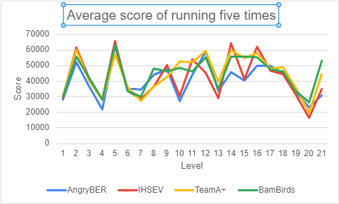

Figure 7: Table of average scores of each level by A.I. agent

For AngryBer agent, it performed poor in levels 2,10,14,15,16 and performed better in levels 7,8. It was performed worst in 4 types A.I. agents. For IHSEV agent, it performed poor in levels 13,17,19,20 and performed better in levels 3,5,9,14,16. For TeamA+ agent, it performed poor at level 7,8,9 and performed better in levels 10,12,18. For BamBirds agent, it performed poor at level 6 and performed better at 8,21. By comparing the scores of them, there are some big differences of the performance in levels 8,10,15. And the A.I. agent have high fail rate in level 20 and level 21. Therefore, the levels 8,10,15,20,21 were chosen for analysis more detail in this report.

The total sum of average score from Four A.I.agents

|  |  |
| --- | --- |
| A.I.agents | Total score |
| AngryBER | 846494 |
| IHSEV | 876694 |
| Team A+ | 932594 |
| BamBirds | 937232 |

**4.3 Level analysis in Angry Birds**

**Colour of arrow symbol**

|  |  |
| --- | --- |
| **Blue is** AngryBer | **Yellow is** TeamA+ |
| **Red is** IHSEV | **Green is** BamBirds |

**Level 8**

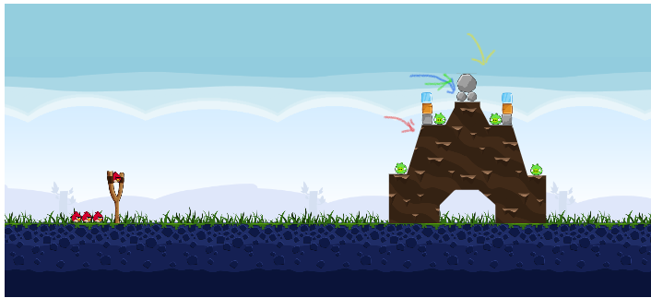

Figure 8: the screenshot of level 8

From figure 7, the first shot of AngerBER and BamBirds agents are all focus on the top of the rock. The difference between them: AngerBER agent is more focus on the smaller rock; Bambirds agent is more focus on the bigger rock. The AngerBer is try to hit the small rock, make the three rocks on the top will fall down to the right-hand side and hit the pig. Then the reflection of hitting the rock will make the bird hit the pig on the left-hand side and push the blocks to the pig which placed in the most left-hand side. In BamBird agent, it shoots the bird to the biggest rock on the top and make it rolling down to right-hand side. In that time, one smaller rock will roll down and hit all the pigs on the left-hand side. These two agents can complete this level in one shot. But TeamA+ and IHSEV agents can’t do the same move in this level. They just aim the target to the pig directly, or just use the smaller rock which is square shape to hit two pigs in one shot at one side luckily.

**Level 10**

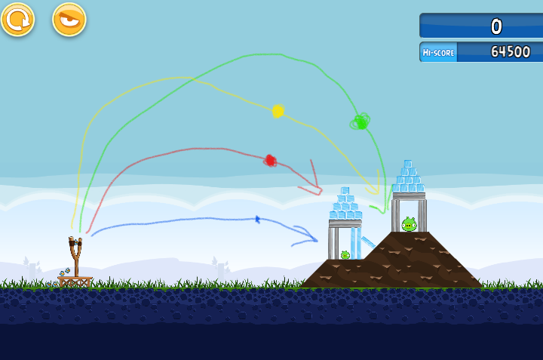

Figure 9: the screenshot of level 10

The spot on the color arrow line is the places of the A.I agent activate the function of the bird. The reason why the TeamA+ and the BamBird agent can get higher score is they can use the blue bird break the three ice plates in the middle first by reflection with the slope. If that three ice’s plates broke, the rock’s plate will drop down and will hit to rock plates which protect the bigger pig at the right-hand side. And the bigger pig will lose the protection and become easy to hit on the next shot.

But the IHSEV agent aim to use the blue bird to hit most ice first. It clears the smaller ice block which in square shape first not the ice plates in the middle. So, it wastes amount of the bird and get lower score. For the AngryBER agent, it just shoots the bird directly to the position of the pig. In Level 10, there are many rocks plates block the trajectory to the pig and the blue bird is hard to against the rock material. Therefore, the AngryBER agent fail in sometimes. The reason is the big would not easy to get hurt if the three ice’s plates don’t remove.

**Level 15**

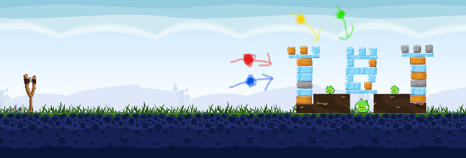

Figure 10: the screenshot of level 15

In level 15, there are three stacks of blocks. The Bambirds and TeamA+ agent can dodge the stack of blocks on left-hand side in the first shot. They break most of the ice’s block in the middle and hit the bigger pig. Then they can finish the level by using two birds, in some test they can hit all the pigs in one shot.

The AngryBER and IHSEV agent always shot the first blue bird to the stack of blocks on left-hand side. After this move, the wood blocks may fall down to the places close to the stack of blocks in the middle. It will block the trajectory of breaking the ice blocks which cover the bigger pig. Therefore, they need spend more bird to the complete this level.

Level 20

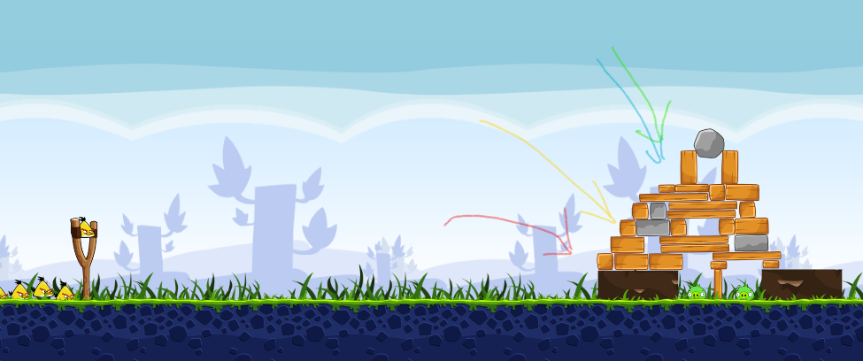

Figure 11: the screenshot of the level 20

AngryBER and Bambirds agent aim the parabola which dodge rock blocks and accelerate the yellow to break the wood pointing to the two pigs. They can use around three shots break the wood’s plate between two pigs. Then the block will fall down and help to hit the pigs like figure 11.

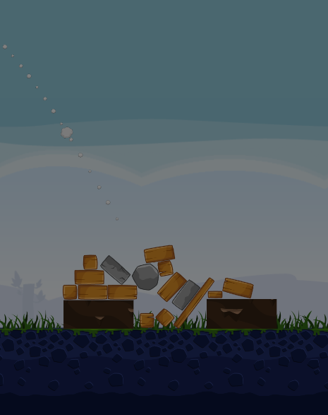

Figure12: the example when the wood plates which placed between two pigs that were broken

In Bambird agent, it maybe jamming the bird and block in the middle. So that, there are not enough of birds to hit the pigs. In AngryBER agent, it maybe has missing shot occurs. It may activate the yellow birds in wrong timing. It makes the yellow birds fly away.

In IHSEV agent, it seems aim to broke the wood on the left-hand side and create space to hit the pig.

**Level 21**

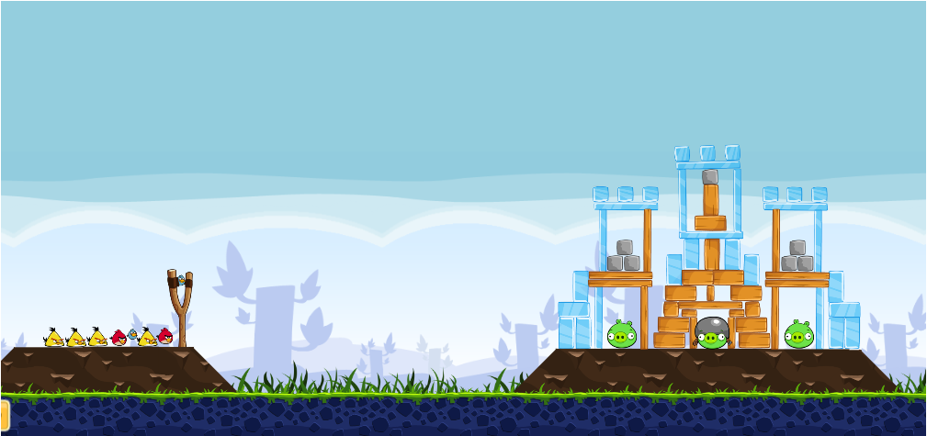

Figure 13: the screenshot of the level 2

In this level, all the A.I. agent try different angle in each shot. The best performance was done by the Bambirds agent. By following step:

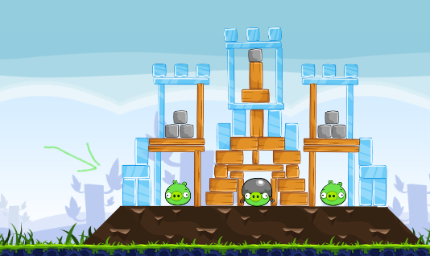 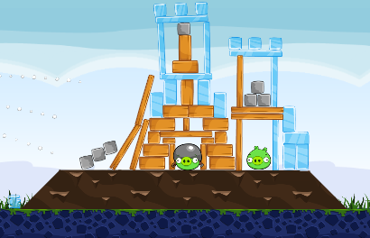 Figure 14: step 1of BamBirds Figure 15: step 2of BamBirds

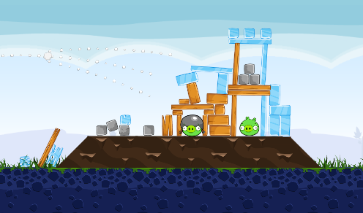

Figure 16: step 15 of BamBirds

Finally, it used one yellow bird hit the remain Pigs to complete the level.

Other three agents, they are more easily make the block stack together and become a thick wood’s wall. It would make the pig in the middle one harder to hit. They need spend more yellow birds to remove the wood block around the pig. Therefore, they got low score and failed.

**4.4 Data collected in Science Birds by custom level**

In this test, there are two A.I. agents were run in Science Birds which were DQ-Birds agent and BamBirds agent. Eight Level were designed to test the A.I. agents. Then it found that there are two level can track the A.I. agents.

|  |  |  |
| --- | --- | --- |
|  | BamBirds | DQ-Birds |
| level1 | pass | pass |
| level2 | pass | pass |
| level3 | fail | fail |
| level4 | pass | pass |
| level5 | pass | pass |
| level6 | fail | fail |
| level7 | pass | pass |
| level8 | pass | pass |

**Analysis of A.I. agents playing level3**

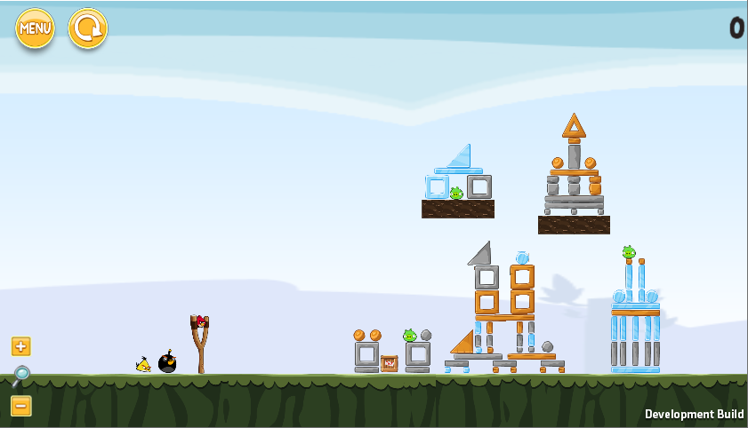

Figure17: screenshot of the level 3

Step of BamBirds agent playing

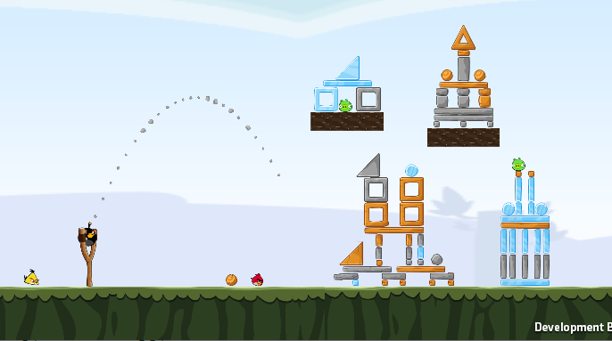 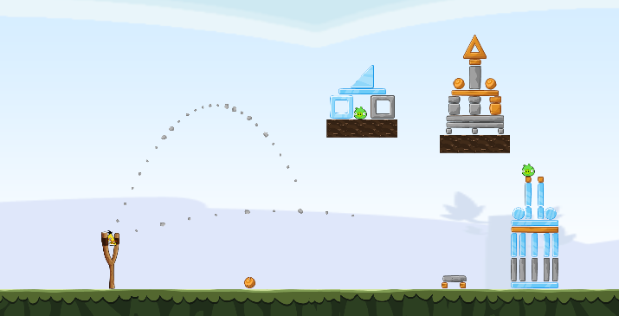

Figure18: first shot in level 3 Figure19: second shot in level3

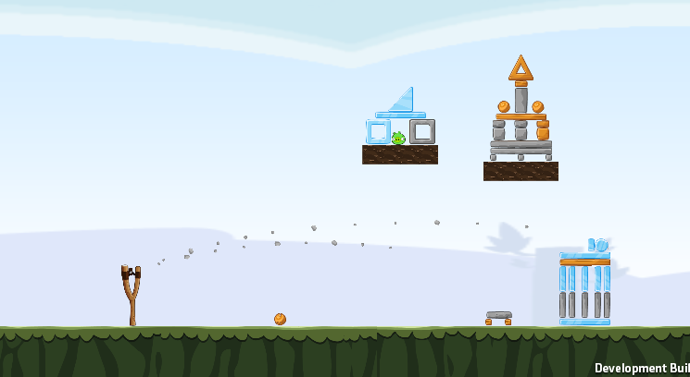

Figure20: last shot in level 3

Step1. Shot the red bird to the TNT bomb

Step2. Shot the black bird and explode it

Step3. Shot the yellow bird to the pig

The Bambirds agent was tricked in the TNT target. It wasted one red bird to shot the TNT. The red bird should use to hit the pig which covered by the ice on the upper side. The level just can be completed when the players don’t use the red bird shot the TNT and use the black bird destory the TNT and the block together in second shot. Then, the last pig could be shoot by the yellow bird.

DQ-Birds agent in Level 3

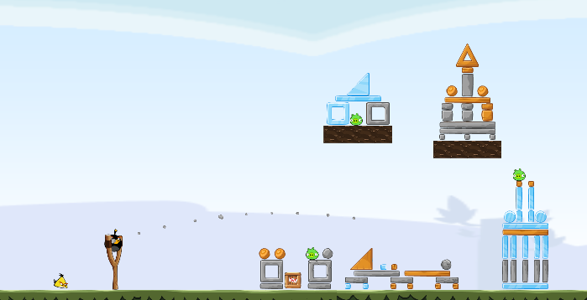 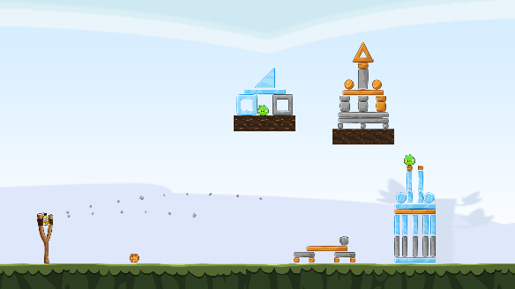

Figure21: first shot in level 3 Figure22: second shot in level 3

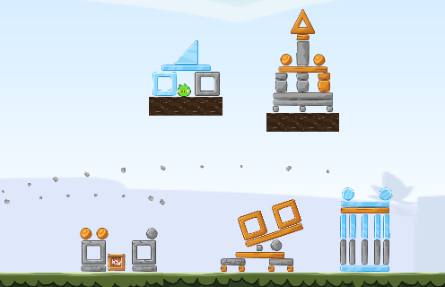

Figure23: third shot in level 3

Step1: red bird use to push down the block in middle.

Step2: black bird use to explode to TNT and hit the pig which places in the middle

Step3: yellow bird use to shoot the pig

DQ-birds agent tried use the red bird to create the path to hit the pig on the right-hand side. But there are still have the problem about not enough bird to hit all the pigs.

**Analysis of A.I. agents playing level6**

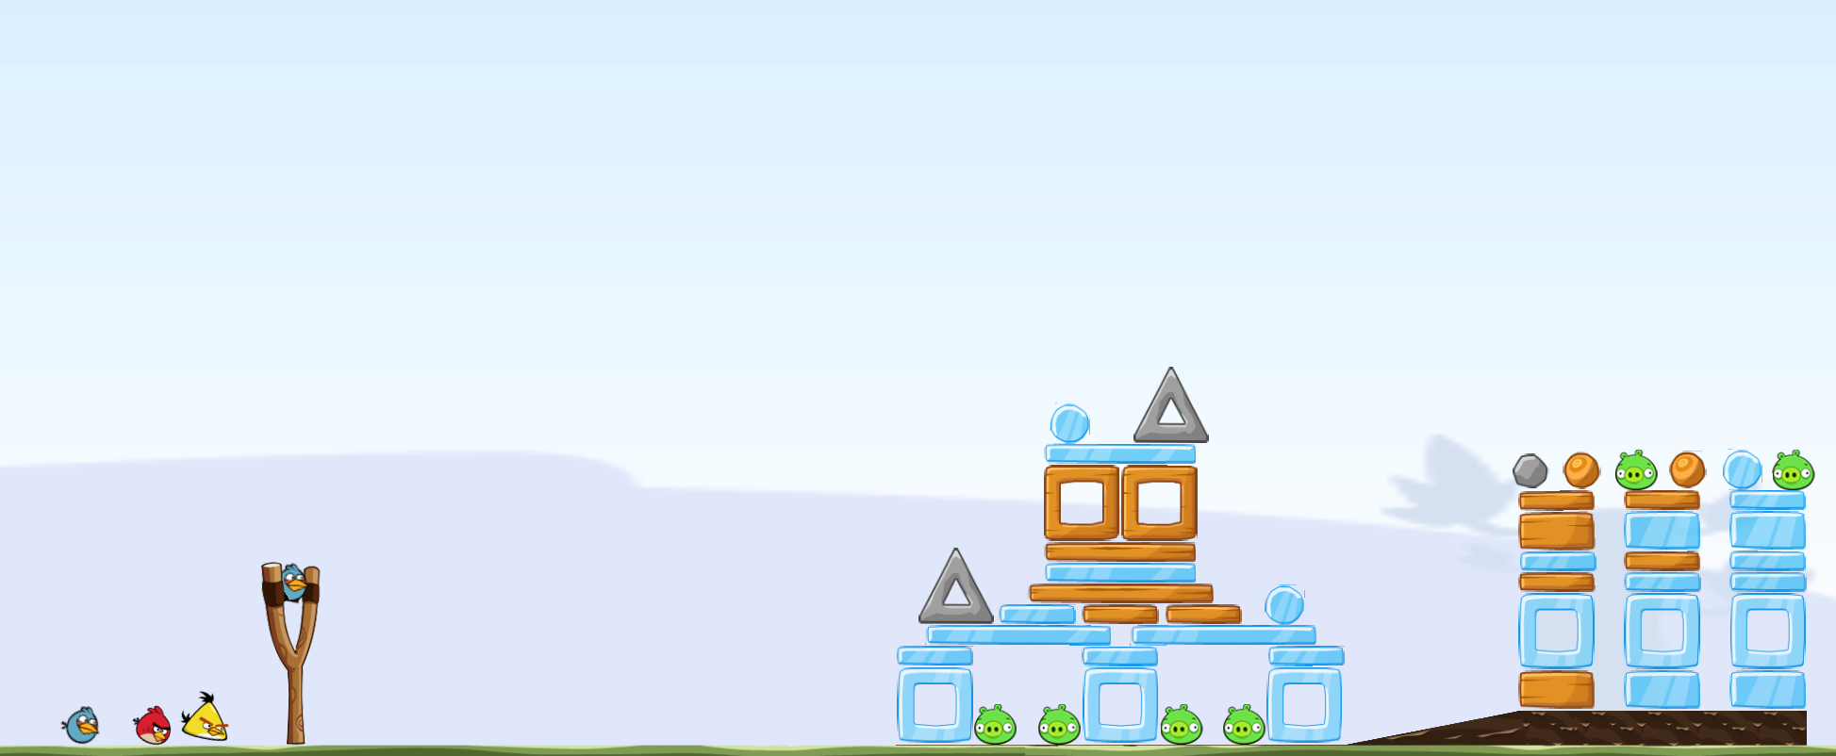

Figure24: screenshot of the level 6

The main reason of Bambirds agents failed is the first shot is too bad. It makes more blocks jamming in front of the two pigs like Figure22.

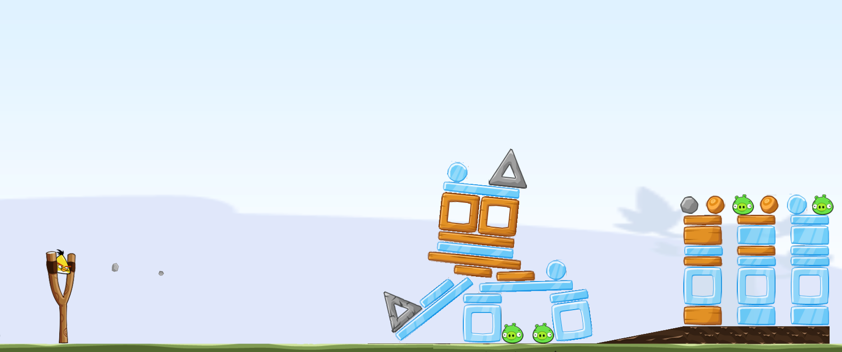

Figure25: the screenshot of Bambirds agent play level 6

In Figure22, It can found that pigs were get more protection after the first shot. The ice blocks will increase if the yellow bird aim the wood block and break the wood blooks. The opportunities of clearing the two pigs which place on the ground will be smaller. This is the main reason after record three times after BamBirds agent play the level 6. The similar problem occurred when the DQ-Birds agent playing level 6, the similar situation like Figure22 happened after first shot.

## **Results and Discussion**

### **5.1 Discussion of the performance of A.I. agent play in Angry Brid**

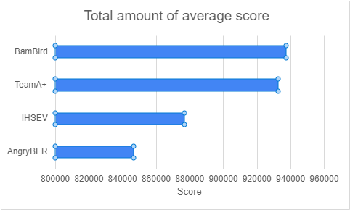

Figure26: Total score of each A.I agents

After finished running the A.I. agents, the BamBirds agent is performed the best between 4 agents. It got 846494 marks. It is reasonable because it is the newest A.I agent compare with others. It was built in 2019. Team A+ got the 2nd high score is reasonable too because the PlanA+ team is the rank 2 in Total Score in A.I. Birds competition from 2014~2017 according the 2017 benchmark from the website: http://aibirds.org/benchmarks.html [3]. But the AngryBER agents got the lowest marks is unexpected. According the information in [3], it is the rank 18 in Total Score in A.I. Birds competition from 2014~2017. The rank of AngryBer is higher than all version of IHSEV’s.

Suggested Improvement

For AngryBER agent,

By observe and analysis the result after running 5 times, it found that its weakness is calculated the path of shooting when topography of the game level has some plate cover the pigs, such as level14, 15. From the coding, the programming in “ShootingAgent.java”, “Feasibility.java”, “abTrajectory.java”, “TrajectoryPlanner.java”, “ActionPobot.jaba”. They can improve the problem by adding more class.

For TeamA+ agent,

Its weakness is detecting the useful objects in the level. For example, using the rock from the top to hit the pigs by falling down. In Level8 and 10, TeamA+ agent got lower score because it just shoots the pigs directly and they didn’t use the rock. It wasted many birds. This problem can be improved by correct the class which they imported into the vision file

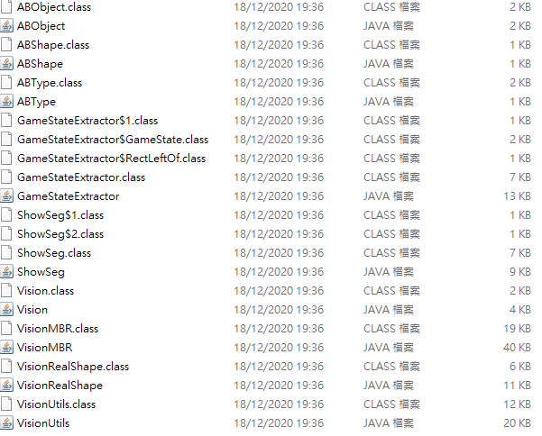

Figure26: JAVA files in vision files(TeamA+ agent)

For IHSEV agent,

It has more problem need to improve. Weak in use and analysis the material at the game level. Also, analysis the situation of the game level need improved, too. It can be improved the Java file in “Vision” category, “HullUtils.java”, “ImageSegementer.java”, "LineSegement.java” for improve analysis the materials. Also, the Java files in “Simulation” should make changes.

For BamBirds agent,

It should be improved the shot priority of different target. The BanBirds agent is designed in aim at shoot the TNT bomb first if the game level has the TNT object. Although the TNT bomb always is the object which is helpful for complete the level, the TNT bomb maybe useless in some level such as custom level “level 3” in Science Birds. Improve the Java files in objects file.

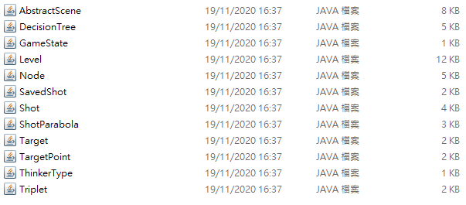

Figure27: the object file in BanBirds agent’s source code.

For DQ-birds agent,

It needs to improve the timing of use of birds and use of TNT. The class may not enough for analysis the function of birds in its Python program.

### **5.2 Deceptive element leads poor shot**

TNT

It is a powerful object in the game because it is the object can destroy the structure and kill the pigs directly by the explosion. It can also make large range damage indirectly. Therefore, most of the players and A.I. agents will aim to target TNT box first for complete the level easily. But they are easy be tricked when the TNT boxes is not effectively like the level 3 in Science Birds in this research.

Angle and timing of activate the birds’ function

Because the different birds have different function. The A.I. agents are designed in activate the birds effectively. It will affect the A.I. agent calculate the path of the shooting birds and timing of activate the function of Birds. The DQ-birds agent and Bambirds agent do the first shot in custom level 6 in Science Birds

Falling and Rolling Object

Use the objects to hit the pigs by falling and rolling can help complete the game level when the amount of the birds is not enough for hitting the pigs by one for one. The rock material is hard to broke, but it is very helpful for destory the structure and the pigs by falling and rolling such as the level 8 in Angry Birds. Therefore, the A.I. agents usually designed using the stone first. It will become the deceptive element when the A.I. agents can’t use it correctly.

## **Conclusion and Further Work**

In this research, there are three deceptive elements were found out by testing the A.I. agent in Angry Birds and Science Birds. They are TNT, falling and rolling object, and Angle and timing of activate the birds’ function. Beside the deceptive elements, some of the weakness of each A.I. agents, such as useless TNT for BamBirds agent, less use falling objects for TeamA+, etc

Although the weakness of A.I agents and some deceptive elements were found in this research, the testing method and the scale can be improved in the future. If some programs were designed for record the shooting target and the path of each shot, it makes people more understand what is the result after the A.I. agents calculated in each shot. It can make the research more accurately by the quantity of the testing increased. In this report, it just run five times in Anry Birds. If the result is come from 30 times or 100 times, more data can use for analysis the A.I. agents. Also, try more different A.I. agents, for example the Datalab team’s agent which get the highest score in the A.I. Birds competition. After the A.I. Birds competition in this year, it will has new version of A.I. agents occur. Hope the code of those A.I.agents is more compatible for latest version of program for machine learing. It is because the code of the A.I. agent from the forum of A.I. Birds Competition is far behind comparig the environment nowadays.

## **References**

1. Renz, Jochen, et al. "Angry Birds as a challenge for artificial intelligence." Proceedings of the AAAI Conference on Artificial Intelligence. Vol. 30. No. 1. 2016.
2. XiaoYu Ge, Stephen Gould, Jochen Renz Sahan Abeyasinghe, Jim Keys, Andrew Wang, Peng Zhang, “Angry Birds Game Playing Software version 1.32”, Research School of Computer Science, The Australian National University, Oct, 2014

[3] AI Birds.org Angry Birds AI Competition. AI Birds.org - Benchmarks. (n.d.). http://aibirds.org/benchmarks.html.

## **Appendix**

**Version of the environment set up**

|  |  |
| --- | --- |
| **JAVA JDK** | **12.0.2 (for Science Birds) / 1.8.0(for Angry Birds** |
| **Apache-ant** | **1.10.9** |
| **Python** | **3.6** |
| **Anaconda** | **4.10.1** |
| **Tensorflow** | **1.15/1.8** |
| **Gradle** | **6.7.1** |
| **SWI-Prolog** | **8.2.4** |
| **NetBeans** | **8.0** |

**Other Custom Game Level in Science Birds**

**Level 1**

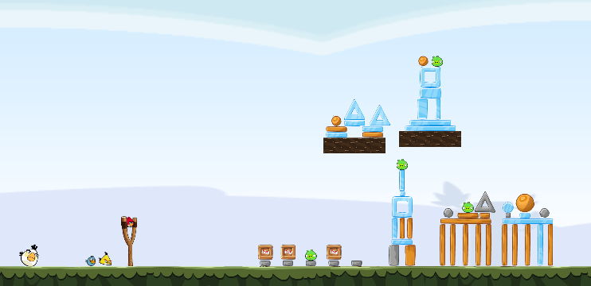

Level 2

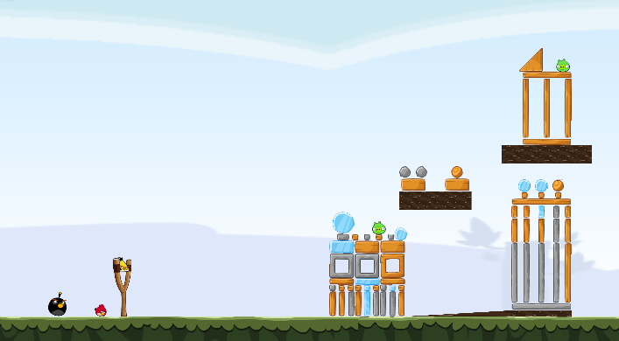

Level 4

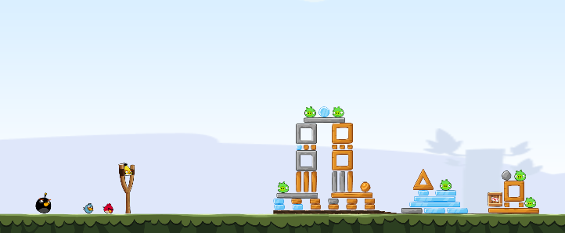

Level 5

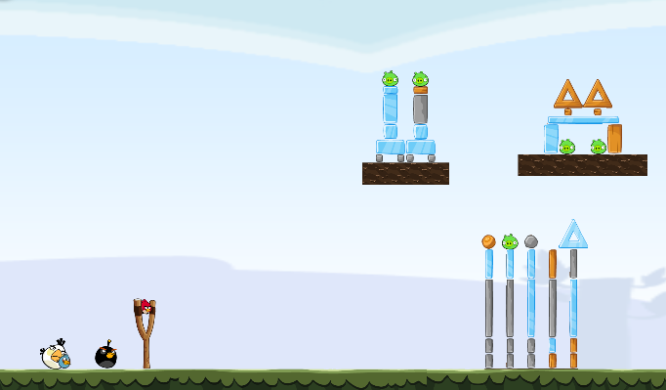

Level 7

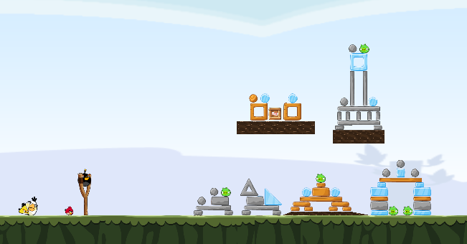

Level 8

